Walk 41 Donnington, Broom’s Green and the parish of Dymock
Last walked in July 2018

Description. 8 km (4.9 miles). A Serene and generally level country lanes and field paths. Taken from Hereford Times July 2013. Long trousers recommended.
Start. Donnington Church. Explorer Map 190 Grid 708344.
Directions from Whitecross Roundabout (Turn milometer to zero). Take the A4110 Canon Pyne (Three Elms road) for 1 mile and TR at the traffic lights onto the A4103 Worcester (Roman road). After 7.7 miles TR, signposted to Stoke Edith. After 9 miles TL at the T-junction (not sign posted) onto main road to Ledbury. Reach roundabout at 15.9 miles and turn R for ‘All Other Traffic. At the next roundabout at 16.4 miles continue on the ‘Thru Traffic. 16.9 miles is the next roundabout keep to ‘All thru Traffic. Next roundabout at 17.1 miles you via R and head along the B4216 for Dymock. At 18.9 miles you TL, signposted for Donnington. A little further on at 19.1 miles by St Mary’s Church you can park in a small lay-by on the R side of the road.

1. St Mary’s Church, Donnington. The Doomsday survey (1085/6) records Donnington to have 6 villagers and 6 smallholders with 7 ploughs and 1 female slave. Value of 25s. An earlier translation, quoted by a former vicar of Donnington, J. E. Gethyn-Jones, in his own History of the Church published in September 1958, describes the female slave as a “bondswoman”. He further adds that “Donnington was then, what it is today, a small agricultural community with about 1,000 acres under cultivation”. With your back to the church, TR and continue along the country road for about 1 km. After about ½ km the road bends R, (ignore the ‘No Thru Road’ going off to the L), continue on to reach a cottage on the L called Nethertways. Nethertways has a red post box in its wall. TR, cross the road and go over a hidden stile and along an overgrown enclosed track for about 30m, then TL to cross over a footbridge and out into F1 via a stile. If this section is to overgrown, go thru the gate into the field and walk a short way along the R field edge to reach the stile. After crossing the stile you go straight across F1, keeping to the R of a line of three mature trees to cross a stile into F2. Keep ahead on the same line, to cross another stile into F3. Walk along the L edge of this large field, (ignore any stiles off to the L) and keep to the R of the farm house, to cross over a stile in the far corner ahead. Walk in and out of a small wooded area via a stile onto a road.

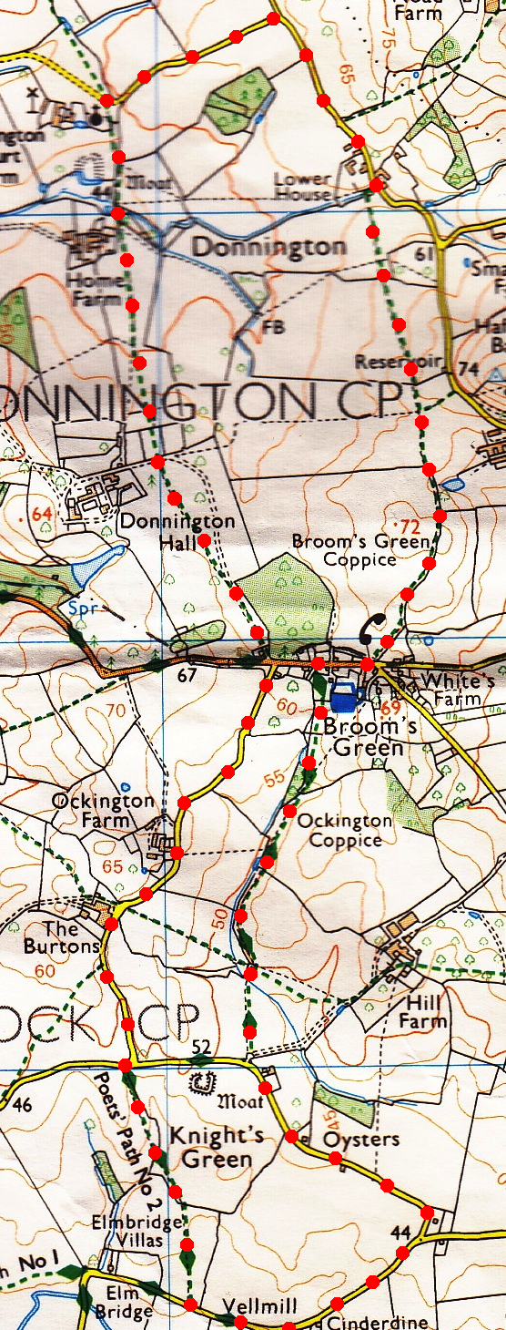
2. Broom’s Green. TR, go passed a red telephone box as you walk along the road for about 100m, and before you get to the 30mph sign posts you TL, and walk along an enclosed public footpath, (Poet’s Path No 2). Cross over a new wooden footbridge and TR along the R edge of F4. Go thru a k-gates into F5 and continue along the R field edge. Go thru a k-gate into an enclosed wooded area and a few paces further on you go thru another k-gate and into F6. TR and Sweep around the R field edge and at the end of this field you go thru a gate gap into F7, ignoring the wide gap in the hedge that’s on your R hand side. Continue along the R edge of this field, near the end it bends R and descends to go straight on across a wooden footbridge over a brook and into an adjoining field F8. Veer slightly L as you cross over this cropped field to cross over a stile. Veer slightly R and walk on a dozen paces to reach the country road, (don’t TL and go over the cattle grid). TL and continue along the country road for about ½ km, the road then bends R and you come to a T-junction. TR for Dymock and Newent and walk along the road for about ½ km to pass Vell Mill cottage, then a few hundred meters further on, (and ignoring any public footpaths going off to the L), reach a small off road car park on your L that opens out onto Vell Mill Meadow Nature Reserve, (has an information board on display).
1

3. Vell Mill Meadow. Continue along the road for about 30m and TR thru a metal gate into F9 to follow Poets Path footpath. Bear half L to cut across the field heading for lone trees. Cross over a wooden footbridge into F10, TR and continue along the R field edge to cross a stile/metal gate onto a road. TR, walk about 20m to a road junction and TL for Broom’s Green. Walk along the road for about a kilometre, passing Burton Farm and Ockington Farm to reach a T-junction at Memorial Hall, an information Board is outside.

4. Road Junction. Cross the road very slightly L and head up the path that’s to the R of Upper Lodge. Go thru two metal gates and then thru a wooden gate/stile into F11. Walk on ahead; keeping to the fence on your L, to reach a stile that’s in the far L hand corner of the field, the stile is next to a metal gate (L) that’s got a card saying ‘Private Land – No Access Without Permission’. (It might be easier to continue along the prominent farm track and TR when you reach the metal gate). Cross over the stile into F12 and continue straight on across the field, heading to the R hand side of buildings ahead. You pass a direction sign post as you make your way to the end of the field, where you continue on thru a gate gap/stile. Keep to the R edge for about 30m then on thru a short enclosed path and over a stony stream bridge and into F13. Ignoring the track that veers off to the L, you continue along the L field edge for 150m to TL across a stile into F14. TR, continue along the R field edge and thru a kissing gate into the church yard. Walk on thru a couple of gates and onto the road and the car,
2
4
3

